Tutorial 11

Module Name: Python - Selenium Navigation & Multi-page Workflow
Test Case ID: TC11
Tester Name: Vora Riya

Scenarios:
- Scenario ID: NAV01
Scenario
Open website
Test Steps
1. Run the Python script.
2. Launch the browser.
3. Navigate to the website.
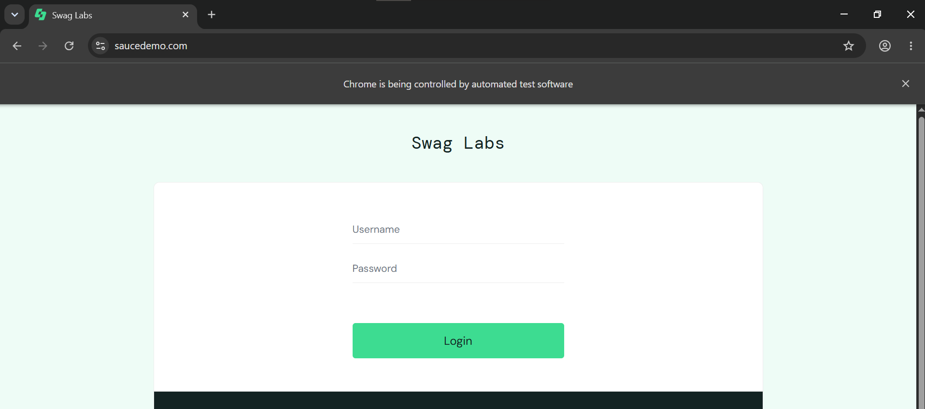

- Scenario ID: NAV02
Scenario
Open Products page
Test Steps
1. Log in.
2. Inspect the inventory page.
3. Verify product names, prices and images.

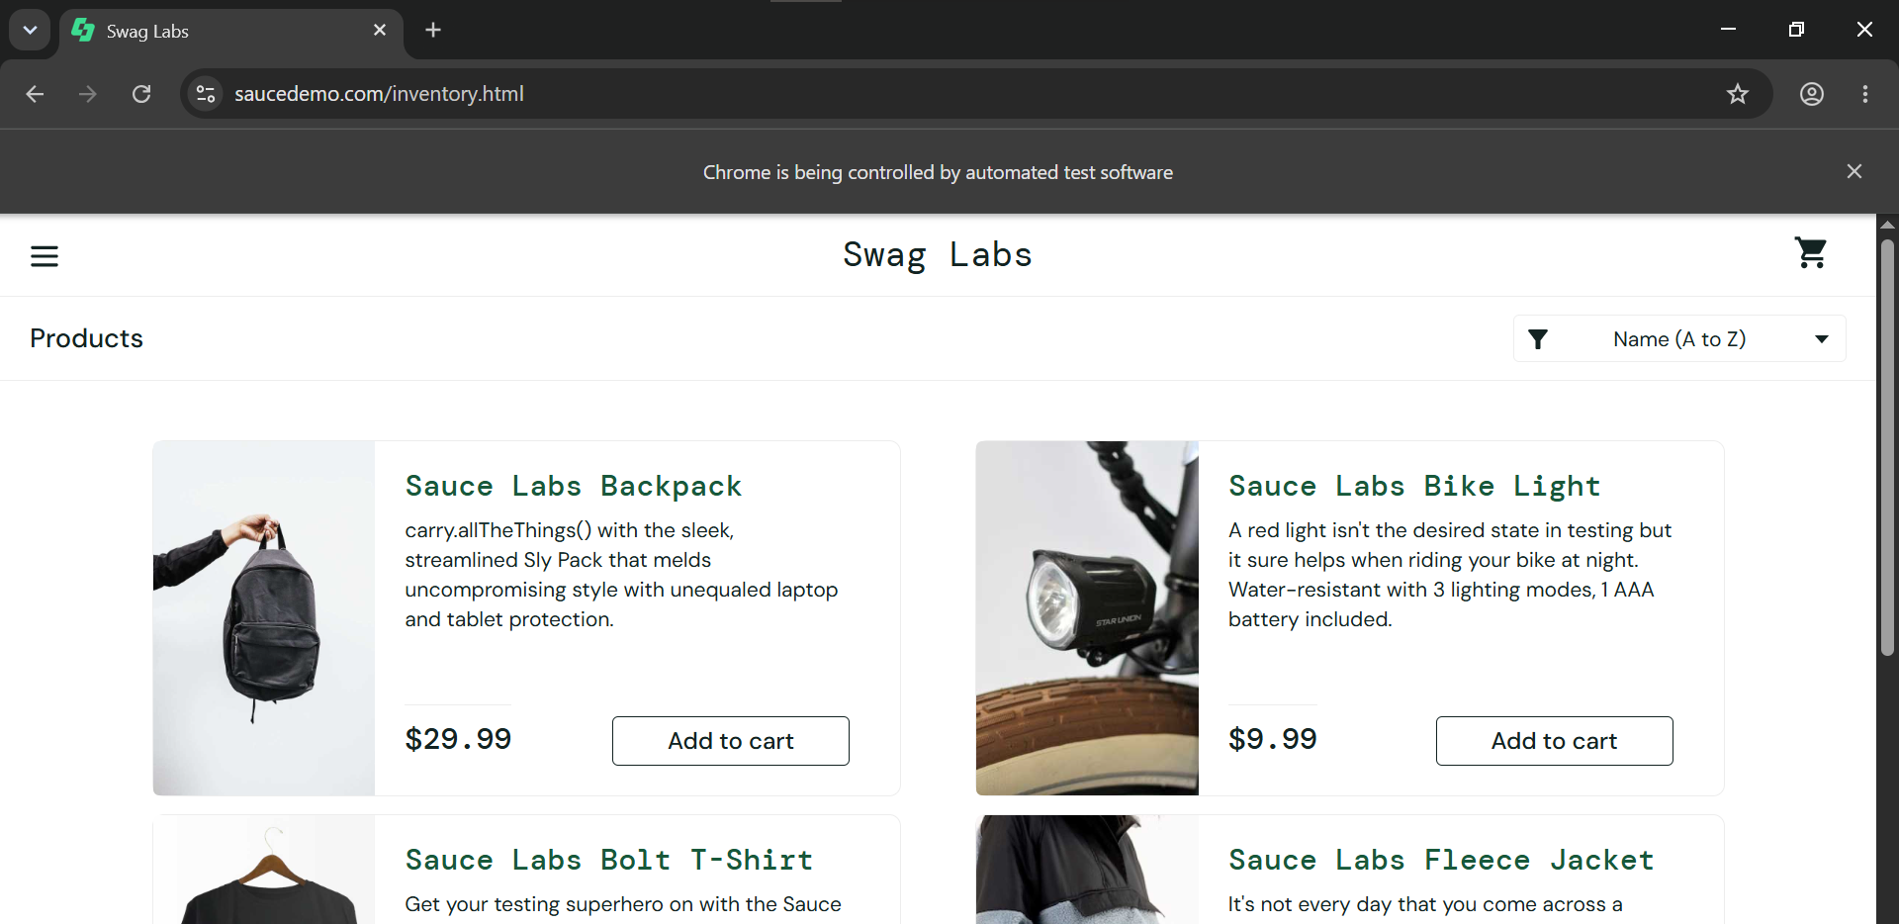

- Scenario ID: NAV03
Scenario
Add to cart
Test Steps
1. Open a product.
2. Click Add to cart.
3. Handle any confirmation dialog if displayed.
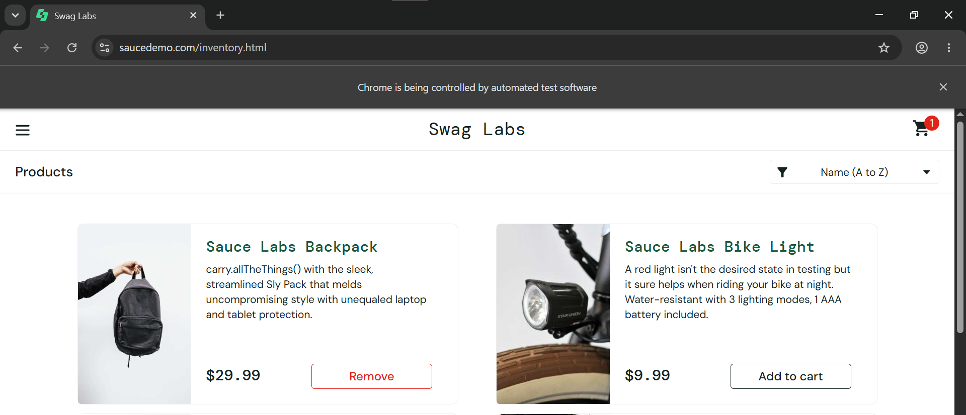

- Scenario ID: NAV04
Scenario
Open cart
Test Steps
1. Add a product to the cart.
2. Navigate to the cart.
3. Verify the cart contents.

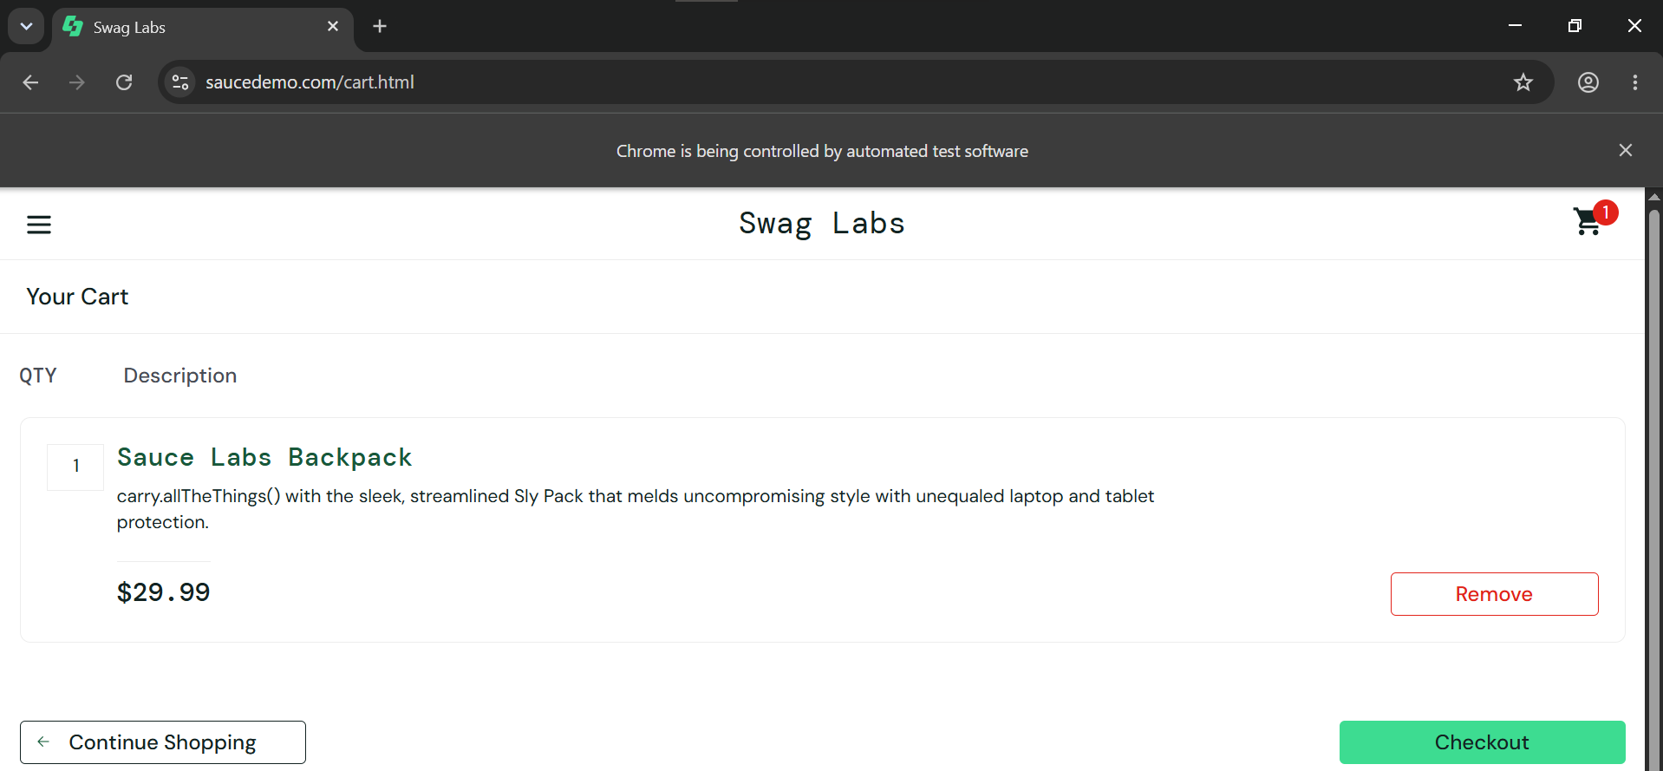

- Scenario ID: NAV05
Scenario
Checkout Page
Test Steps
1. Add a product to the cart.
2. Navigate to the cart.
3. Add information and checkout

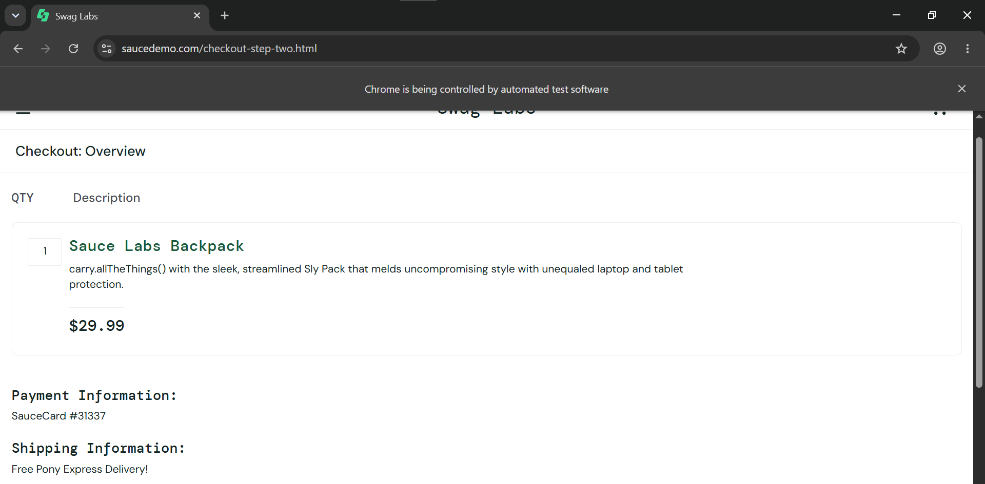

- Code:
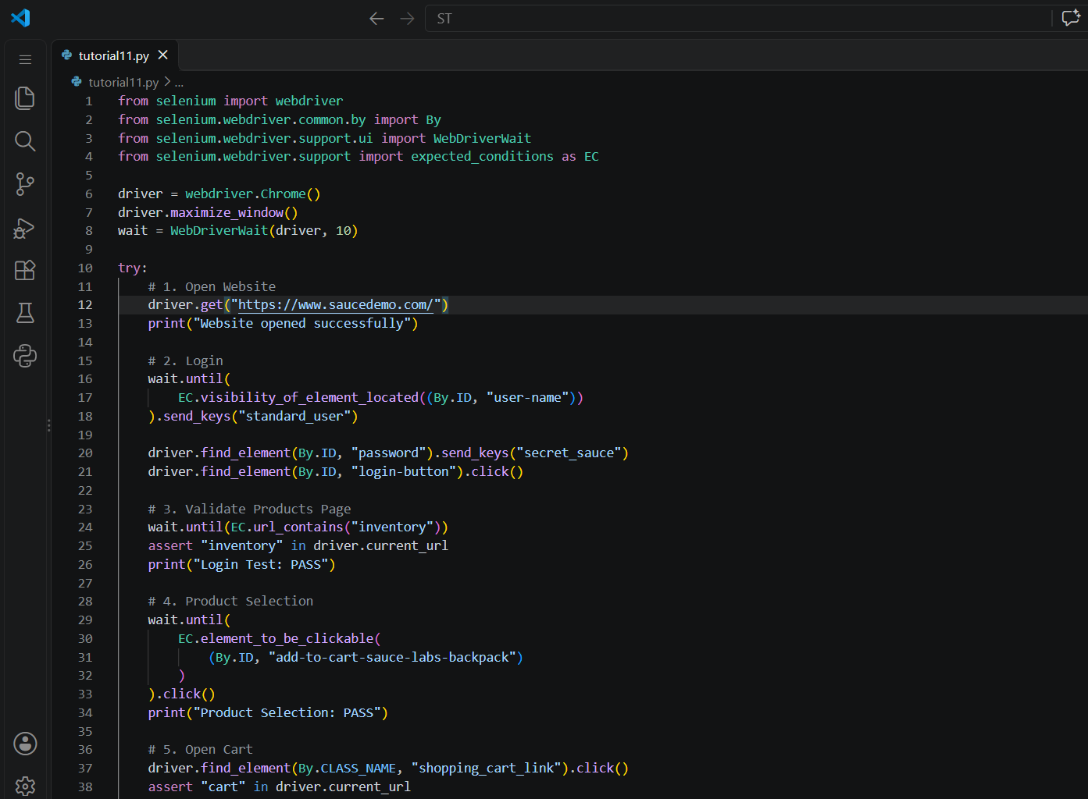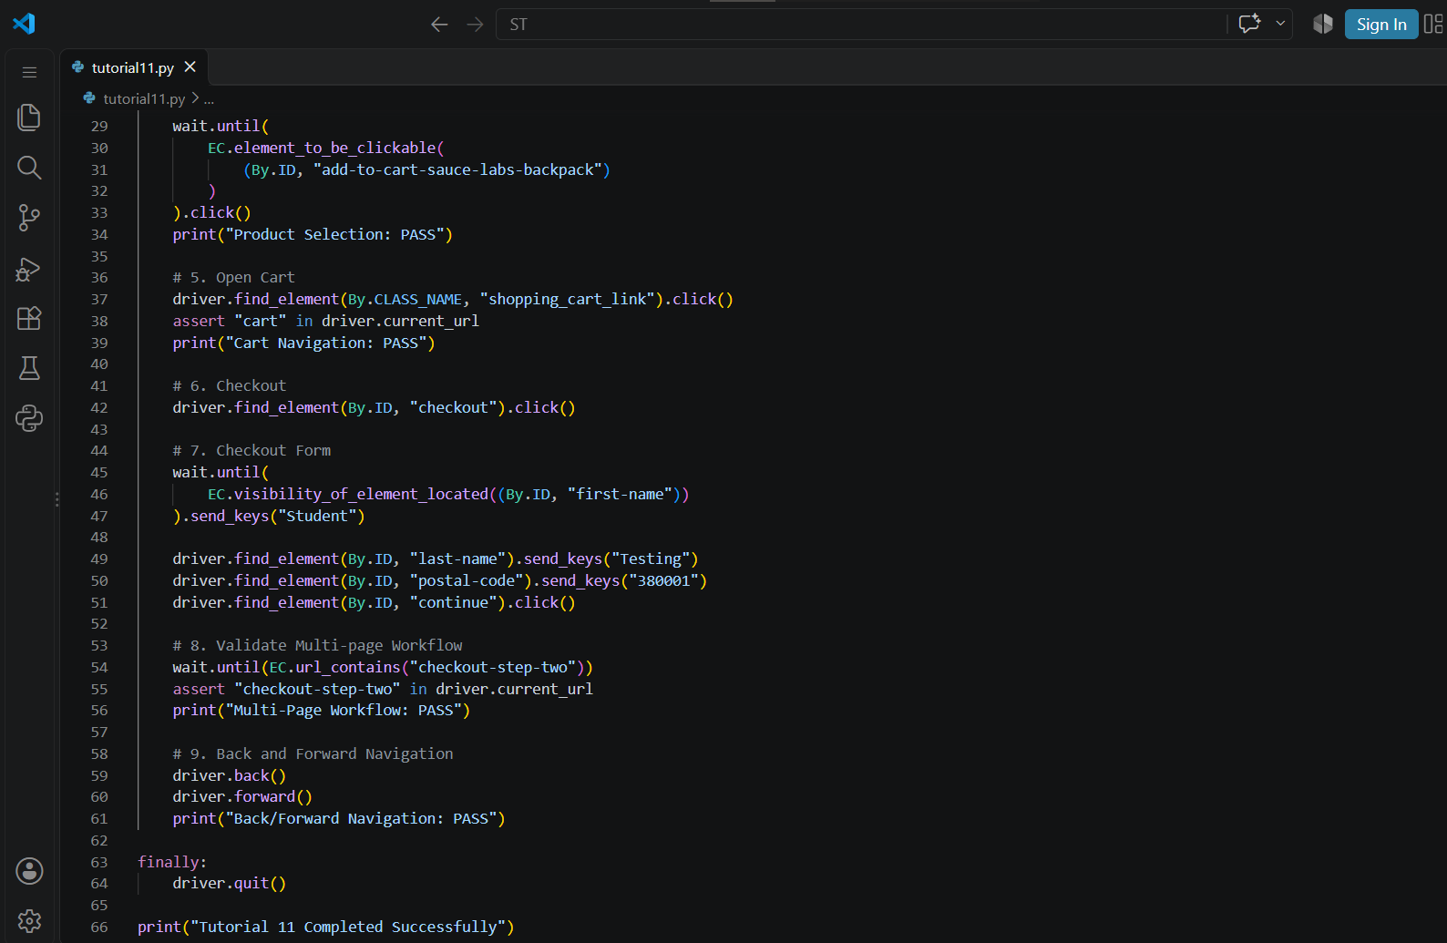

- Console Output:
